

Assessment Cover Page
Student Full Name
Valeria Cantu Angel
Student Number
2026679
Module Title
Statistical Techniques for Data Analysis
Assessment Title

Statistical Techniques for Data Analysis CA-1Si

Lecturer/Supervisor
Taufique Ahmed
Assessment Due Date
01/11/2026
Date of Submission
01/11/2026
Use of AI Tools

I acknowledge the use of ChatGPT for the purpose of dataset preparation, python code generation, explanation of statistical methods and revision of sections of this report.
Declaration
By submitting this assessment, I confirm that I have read the CCT policy on academic misconduct and understand the implications of submitting work that is not my own or does not appropriately reference material taken from a third party or other source.
I declare it to be my own work and that all material from third parties has been appropriately referenced.
I further confirm that this work has not previously been submitted for assessment by myself or someone else in CCT College Dublin or any other higher education institution.

One Year Business Survival in Ireland
A Statistical Analysis of Birth Cohorts 2019-2023

Contents
Table of Contents
Introduction. 2
Dataset and Data Preparation. 2
Descriptive Statistics and Visualisation. 3
Binomial and Poisson Distributions. 7
Poisson Distribution. 8
Normal Distribution. 9
Comparison and Conclusions. 11
References. 11

Introduction.

This report analysis business creation and one year survival rates across 16 distinct economic sectors in Ireland, examining cohorts of businesses established between 2019 and 2023. The analysis utilizes data from the CSO (Central Statistics Office) specifically the BRA36 dataset, which tracks both the creation of businesses and those that remain active one year later.
Descriptive statistics and visual representations have been developed to examine differences across the various sectors and cohorts. Furthermore, binomial, Poisson and normal distributions have been applied to analysis business survival and the number of businesses created. The report also addresses the assumptions and limitations of these models, including the presence of missing data, unequal representation across sectors, and discrepancies between actual data and the results derived from theoretical models.

Dataset and Data Preparation.

The data analysis utilizes the “BRA36 Enterprise Survival” dataset, provided by the CSO (by Central Statistical Office. A table has been constructed containing 80 observations, corresponding to 16 broad economic sectors. Additionally, five distinct business creation cohorts are included, covering the period from 2019 to 2023. Each observation represents a combination of an economic sector and a business creation cohort. The economic sector and the business creation cohort are categorical variables. The number of businesses created, the number of people employed at the time of creation, and the number of surviving businesses are quantitative variables. The survival rate was calculated using the following formula:
The survival rate was calculated by dividing one year survivors by births from the same cohort and multiplying by 100
Broad economic sectors were selected to ensure there was no overlap between them. These include businesses of all sizes. Businesses that survived in a given year were assigned to the business creation cohort corresponding to the previous year.
There is missing data regarding the number of businesses created, 2 observations contain missing values. Furthermore, there are 5 observations with missing data concerning the number of people employed at the time of creation. The missing values were not replaced with zeros. Consequently, there are 78 observations available that contain data on both the number of businesses created and the number of surviving businesses.

Descriptive Statistics and Visualisation.

The numerical variables show significant, differences within the data. For example, the mean value for business creation is 2,341.24 a figure substantially higher than the median 1,947. This indicates the presence of high values in the dataset, which pull the mean upward. The standard deviation is also quite high 2,382.94.

Both the number of people employed, at the time of a business creation and the number of businesses that survive after one year show mean values that exceed their respective medians. This suggest that it would be useful to analysis the distribution of the data. These statistics provide only a general overview of the data for the sector as whole, they do not offer information regarding individual businesses.

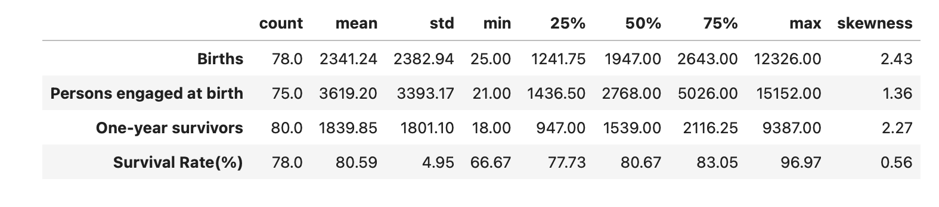

Table 1. Descriptive statistics for the prepared dataset.

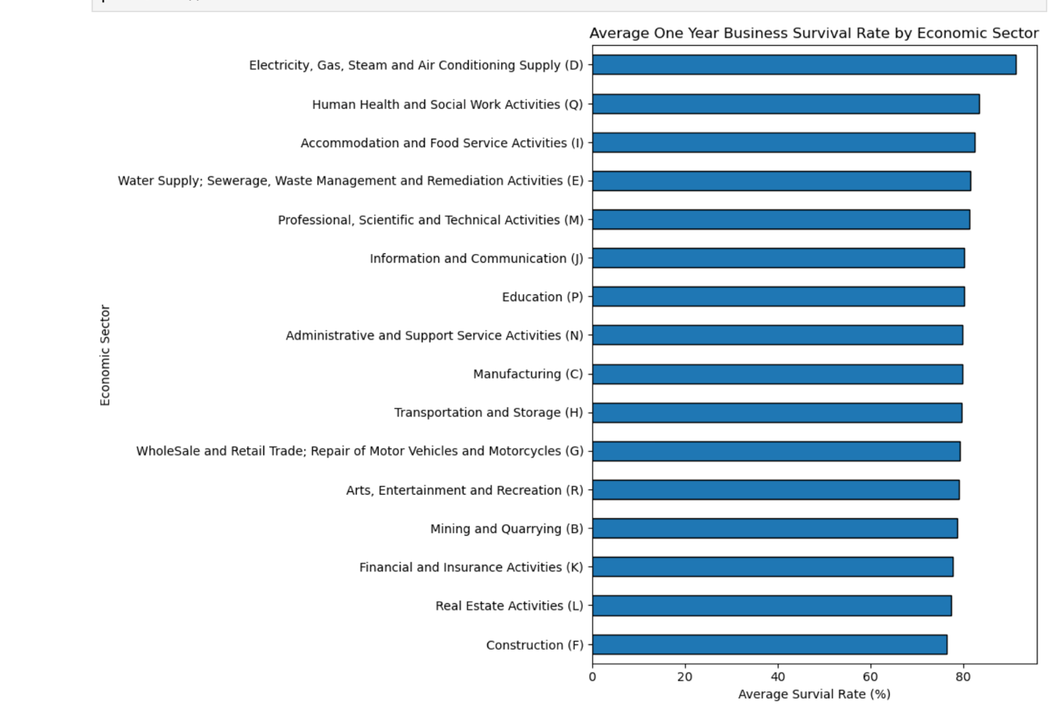

Figure 1. Mean one year survival rate by economic sector.

A horizontal bar chart was chosen to show the differences between the various sectors. The highest average survival rate was found in the electricity, gas, steam, and air conditioning supply sector, with an average of approximately 91.32%. The lowest average survival rate was observed in the construction sector, with an average of approximately 76.37%.

This does not provide any explanation as to why the companies survived. Furthermore, the average for the financial sector was calculated based on three cohorts, whereas for the other sectors, it was based on five.

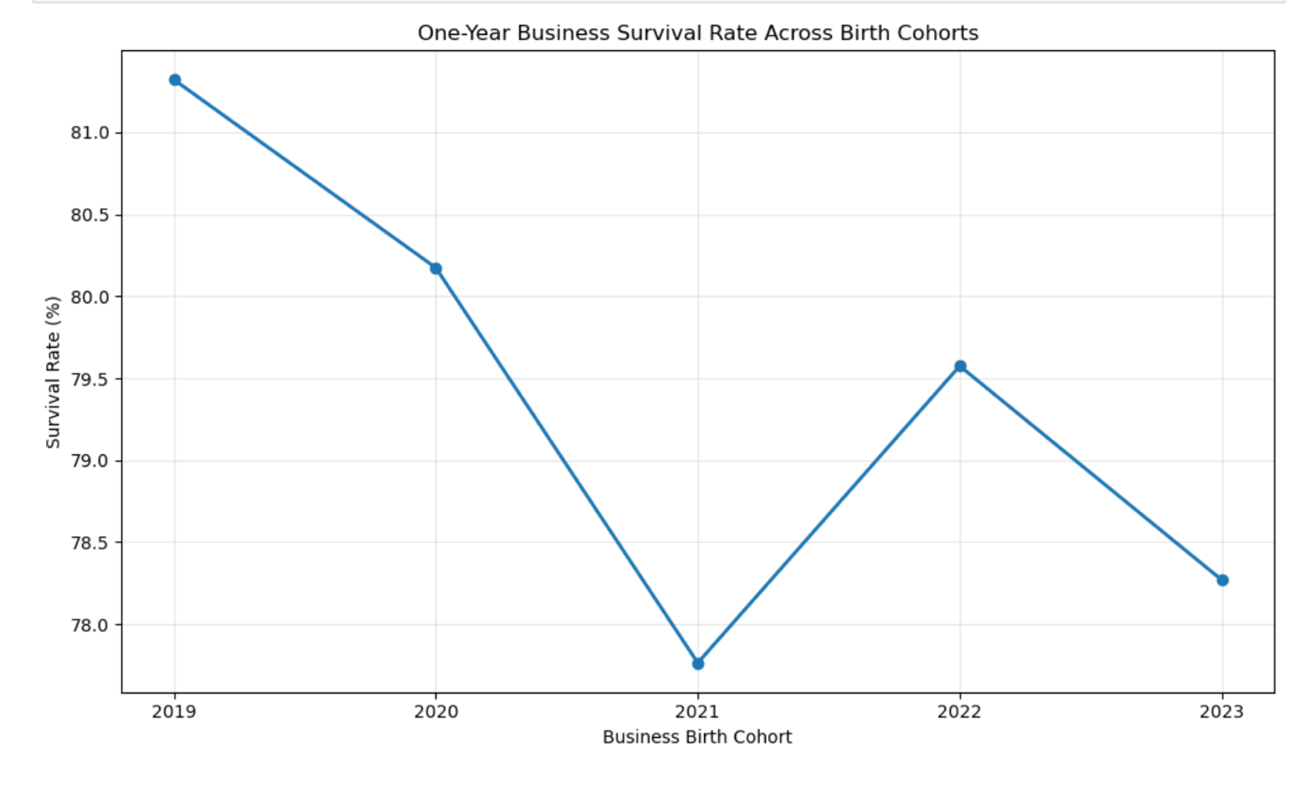

Figure 2. Pooled one year survival rate by birth cohort.

The line graph shows the birth cohorts in order, along with their combined survival rates. The overall survival rate was approximately 81% for the 2019 cohort and 78% for the 2023 cohort. Some variation was observed between the cohorts. The combined survival rates are weighted according to the number of births recorded in each sector. This figure should be interpreted with caution as there were 15 sectors with comparable data between 2019 and 2020, compared to 16 sector between 2021 and 2023.

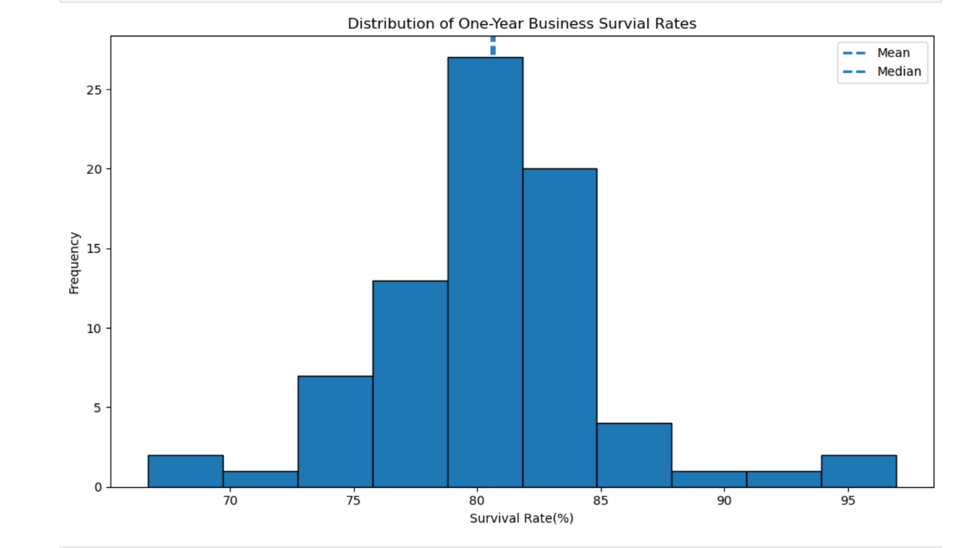

Figure 3. Distribution of sector cohort one year survival rates.

This histogram shows the central tendency, dispersion, and shape of the 78 available survival rates. The mean was 80.59% and the median was 80.67%. The standard deviation was 4.95 percentage points.
The skewness value of 0.564 indicates that the data exhibit positive skewness. Although the central tendency appears to be fairly symmetrical, there are some high values in the upper tail. For this reason, it would be advisable to investigate whether these data can be approximated by a normal distribution.

Binomial and Poisson Distributions.

A binomial distribution has been applied to model the number of firms that will survive after one year, based on a hypothetical sample of 100 new firms. Each firm has two possible outcomes. The probability of a firm’s survival has been calculated by taking the number of surviving firms (144,703), and dividing it by the total number of firms created, as obtained from the matched dataset (182,617). This yields a value of p = 0.792385. This figure differs from our unweighted average survival rate (80.59%) because we are using a weighted average.

The binomial distribution relies on certain simplifying assumptions, that each outcome is independent and that the probability of survival is constant. In reality, survival rates. Vary by sector and cohort, and firms may be affected by similar economic shocks.
$$P\left(X=k\right)=\frac{n!}{k!\left(n-k\right)!}p^{k}{\left(1-p\right)}^{n-k}$$

For n = 100, the average number of surviving companies would be 79.24. There is a 9.75% probability that exactly 80 companies will survive, and a 48.39% probability that at least 80 companies will survive. These values were calculated using the binomial probability mass function and the survival function from SciPy.
This shows the probability of specific outcomes occurring under these assumptions. It does not guarantee that any given group of companies will yield these results.

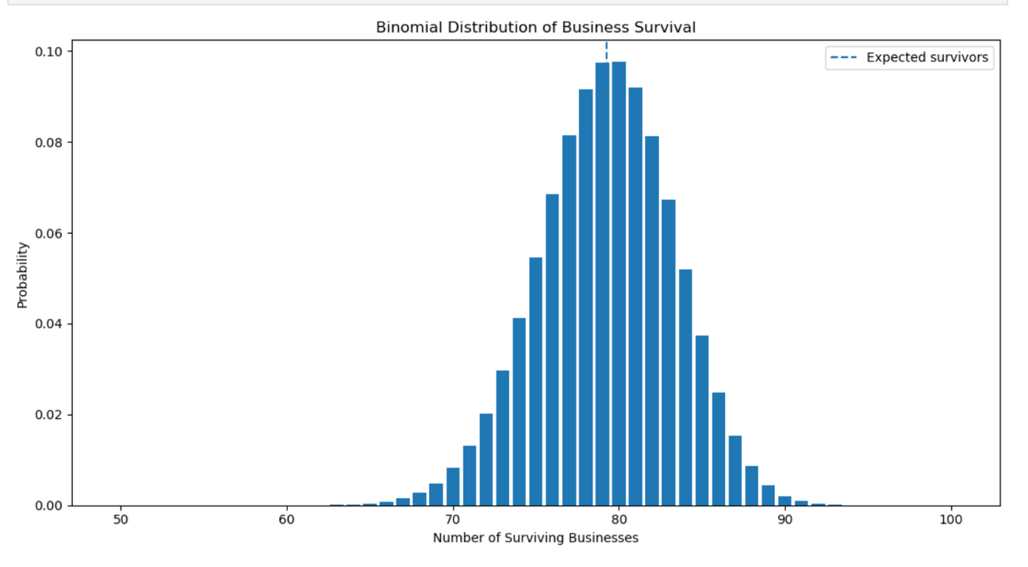
Figure 4. Binomial distribution of survivors among 100 new enterprise, using p = 0.792385.

Increasing the group size from 30 to 100 and 500 increased expected survivors to approximately 23.77, 79.24 and 396.19. The standard deviation of the count also increased, but more slowly than group size, indicating lower proportional variability under the model assumptions.

Poisson Distribution.
The initial distribution assumed was a Poisson distribution. This has a parameter lambda which is calculated by findings the mean of the 78 available birth counts. The result is approximately 2341.24
The Poisson model assumes that the events are independent and occurred at a constant rate, both the mean and variance are equal to lambda.
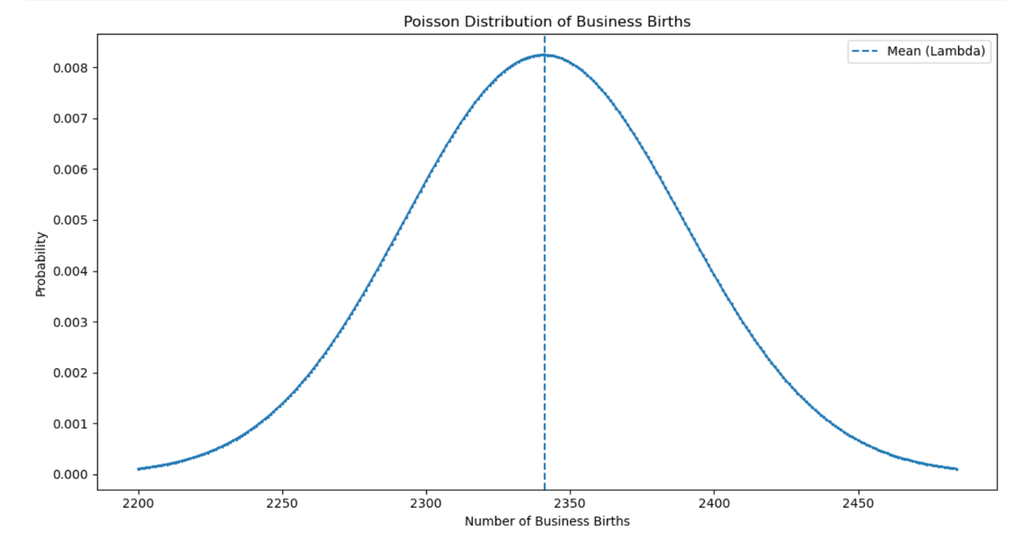

Figure 5. Hypothetical Poisson benchmark for sector year enterprise births, using lambda = 2341.24
The probabilities describe the hypothetical benchmark and should not be treated as validated predictions of actual sector year births.

Normal Distribution.

A normal distribution was used to model the 78 survival rates available by sector and cohort. The mean of the distribution was set at 80.59% with a standard deviation of 4.95 percentage points. Using the normal distribution function provided by SciPy, we can observed that a survival rate of 85% corresponds to a z-score of approximately 0.89. This means there is an 81.34% probability that the rate are below 85%, and an 18.66% probability that they are above 85%. However, we have observed that 91.03% of the rates fall below this value. This indicates that our model does not accurately reflect our data.

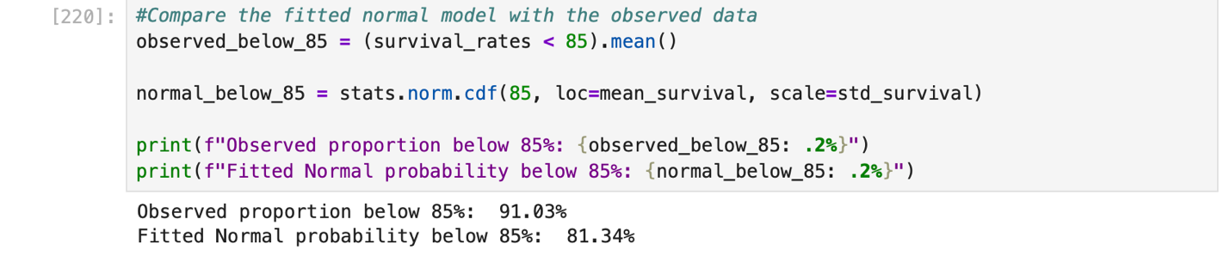

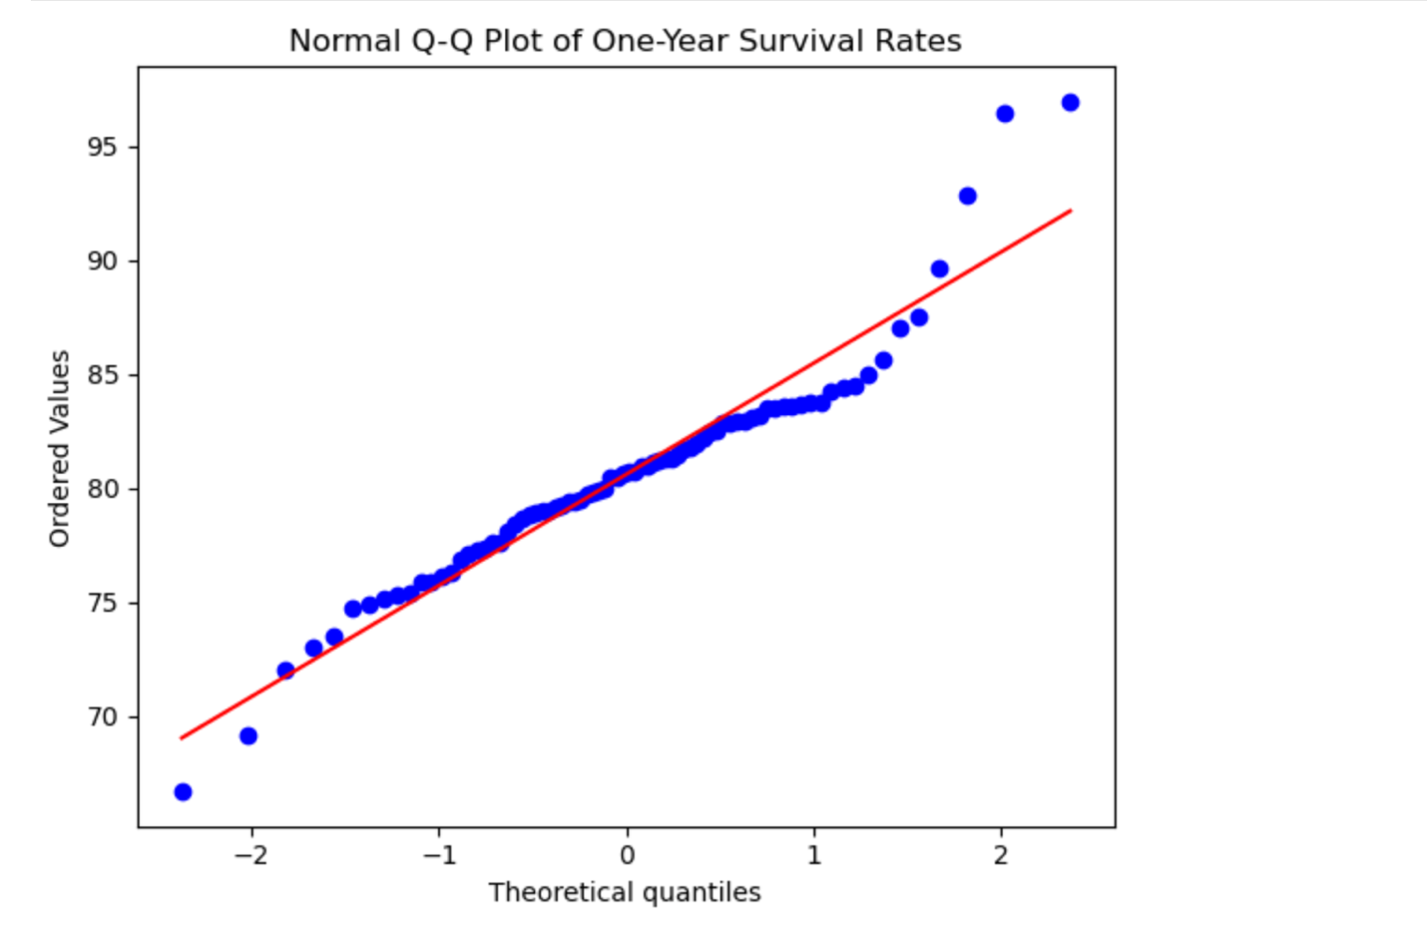
Figure 6. Normal Q-Q Plot of sector cohort Survival Rates.
This graph compares the observed rate with the theoretical quantiles of a normal distribution. The central values lie reasonably close to the reference line, however there are outliers at both ends, with a higher concentration at the upper end. Given the positive skew of the data and the fact that the percentages are bounded, a normal distribution which has no such limits, cannot serve as a complete approximation. This demonstrates that, while the central values may follow a normal distribution, it does not imply that the distribution as a whole does so.
This reenforce the notion that such a normal distribution should be considered an approximation rather than a validated predictive model. Furthermore, one should exercise caution when using the provided probabilities, as extremely high or low rates could happen.

Comparison and Conclusions.

The binomial distribution was used to show the probability of multiple new enterprises surviving. It is based on the assumption that all new enterprises have the same probability of surviving and are mutually independent. The Poisson distribution was used to show the number of births within a sector over one year. The observed variance was much greater than the mean, indicating that single common rate Poisson was unsuitable for the pooled counts.

The normal distribution was used to describe the survival rates in sector cohorts. However the prediction is not very accurate because there were differences between the predicted values.
A binomial distribution can be approximated by a normal distribution if both are large enough. In the case of the 100 new enterprises this would be 79.24 and 20.76 therefore showing that it can be approximated. A Poisson distribution becomes more normal as lambda gets larger.

However this does not help the accuracy issue. The unweighted mean survival rate was 80.59%. The pooled proportion was 79.24%. The lowest mean across sectors was in construction and the highest was in electricity, gas, steam and air conditioning supply. It does not explain why there are differences. Overall when selecting which distribution to use it is important to look at the assumptions made about the data. Missing values and different coverage across sectors should be considered when interpreting results.

References.
Central Statistics Office (n.d.) BRA36 – Enterprise Survival
NACE Rev 2 [Dataset]. Available at:
https://data.gov.ie/dataset/bra36-enterprise-survival-nace-rev-2
(Accessed: 20 October 2026).

SciPy (n.d.-a) scipy.stats.binom. SciPy documentation.
Available at:
https://docs.scipy.org/doc/scipy/reference/generated/scipy.stats.binom.html
(Accessed: 24 October 2026).

SciPy (n.d.-b) scipy.stats.norm. SciPy documentation.
Available at:
https://docs.scipy.org/doc/scipy/reference/generated/scipy.stats.norm.html
(Accessed: 24 October 2026

SciPy (n.d.-c) scipy.stats.poisson. SciPy documentation.
Available at:
https://docs.scipy.org/doc/scipy/reference/generated/scipy.stats.poisson.html
(Accessed: 24 October 2026).

SciPy (n.d.-d) scipy.stats.probplot. SciPy documentation.
Available at:
https://docs.scipy.org/doc/scipy/reference/generated/scipy.stats.probplot.html
(Accessed: 24 October 2026).

